

Lab Manual: Mechatronic Systems Analysis

Using the Quanser Mechatronic Systems Board for NI ELVIS III

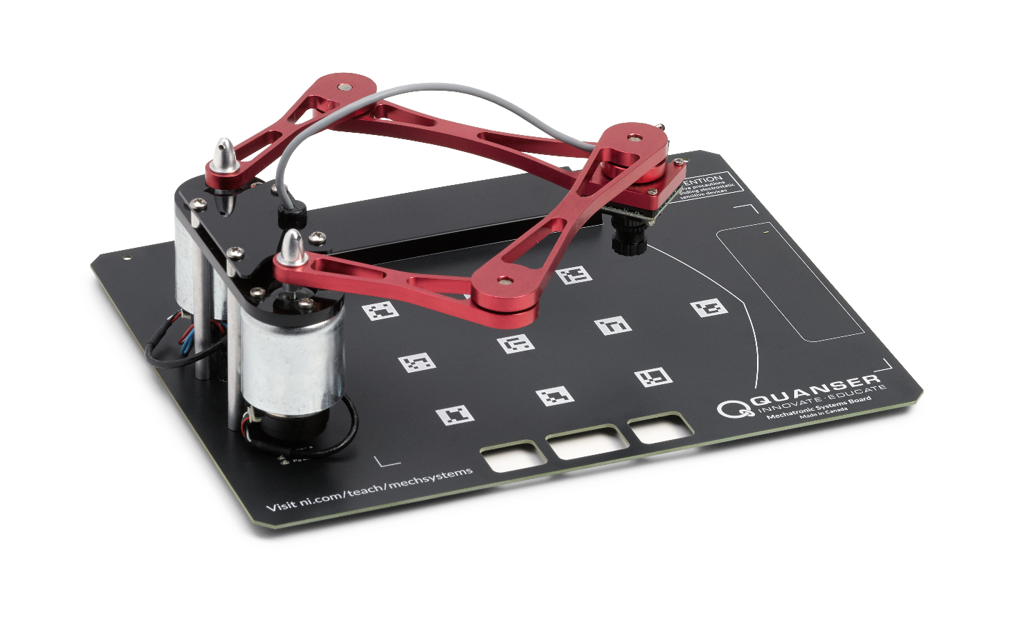

© 2018 Quanser Inc., All Rights Reserved

Printed in Markham, Ontario.

This document and the software described in it are provided subject to a license agreement. Neither the software nor this document may be used or copied except as specified under the terms of that license agreement. Quanser Inc. grants the following rights: a) The right to reproduce the work, to incorporate the work into one or more collections, and to reproduce the work as incorporated in the collections, b) to create and reproduce adaptations provided reasonable steps are taken to clearly identify the changes that were made to the original work, c) to distribute and publically perform the work including as incorporated in collections, and d) to distribute and publicly perform adaptations. The above rights may be exercised in all media and formats whether now known or hereafter devised. These rights are granted subject to and limited by the following restrictions: a) You may not exercise any of the rights granted to You in above in any manner that is primarily intended for or directed toward commercial advantage or private monetary compensation, and b) You must keep intact all copyright notices for the Work and provide the name Quanser Inc. for attribution. These restrictions may not be waved without express prior written permission of Quanser Inc.

LabVIEW and National Instruments are trademarks of National Instruments.

All other trademarks or product names are the property of their respective owners.

**Additional Disclaimers:** The reader assumes all risk of use of this resource and of all information, theories, and programs contained or described in it. This resource may contain technical inaccuracies, typographical errors, other errors and omissions, and out-of-date information. Neither the author nor the publisher assumes any responsibility or liability for any errors or omissions of any kind, to update any information, or for any infringement of any patent or other intellectual property right.

Neither the author nor the publisher makes any warranties of any kind, including without limitation any warranty as to the sufficiency of the resource or of any information, theories, or programs contained or described in it, and any warranty that use of any information, theories, or programs contained or described in the resource will not infringe any patent or other intellectual property right. THIS RESOURCE IS PROVIDED “AS IS.” ALL WARRANTIES, EITHER EXPRESS OR IMPLIED, INCLUDING, BUT NOT LIMITED TO, ANY AND ALL IMPLIEDWARRANTIES OFMERCHANTABILITY, FITNESS FOR A PARTICULAR PURPOSE, AND NON-INFRINGEMENT OF INTELLECTUAL PROPERTY RIGHTS, ARE DISCLAIMED.

No right or license is granted by publisher or author under any patent or other intellectual property right, expressly, or by implication or estoppel.

IN NO EVENT SHALL THE PUBLISHER OR THE AUTHOR BE LIABLE FOR ANY DIRECT, INDIRECT, SPECIAL, INCIDENTAL, COVER, ECONOMIC, OR CONSEQUENTIAL DAMAGES ARISING OUT OF THIS RESOURCE OR ANY INFORMATION, THEORIES, OR PROGRAMS CONTAINED OR DESCRIBED IN IT, EVEN IF ADVISED OF THE POSSIBILITY OF SUCH DAMAGES, AND EVEN IF CAUSED OR CONTRIBUTED TO BY THE NEGLIGENCE OF THE PUBLISHER, THE AUTHOR, OR OTHERS. Applicable law may not allow the exclusion or limitation of incidental or consequential damages, so the above limitation or exclusion may not apply to you.

Table of Contents

Introduction 6

Learning Objectives 6

Prerequisites 7

Completed Courses 7

Hardware, Software, and Tool Knowledge 7

Organization of the Lab Manual 8

Lab 1: Interfacing with Motors 8

Lab 2: Controlling Manipulators 8

Lab 3: Processing Images 9

Lab 4: System Level Control 9

Lab Tools and Technology 10

Platform: NI ELVIS III 10

Hardware: Quanser Mechatronic Systems Board 11

Software: LabVIEW 12

Lab 2: Controlling Manipulators 13

Learning Objectives 14

Required Tools and Technology 15

Expected Deliverables 16

Section 1: PID Joint Control 17

1.1 Theory and Background 17

1.2 Implement 21

1.3 Analyze 23

Section 2: Forward Kinematics 25

2.1 Theory and Background 25

2.2 Implement 27

2.3 Analyze 28

Section 3: Inverse Kinematics 30

3.1 Theory and Background 30

3.2 Implement 32

3.3 Analyze 34

Section 4: Manipulator Control 35

4.1 Theory and Background 35

4.2 Implement 36

Lab 3: Processing Images 38

Learning Objectives 39

Required Tools and Technology 40

Expected Deliverables 41

Section 4: Image Processing 42

4.1 Theory and Background 42

4.2 Implement 43

Lab 4: System Level Control 47

Learning Objectives 48

Required Tools and Technology 49

Expected Deliverables 50

Section 1: State Machines 51

1.1 Theory and Background 51

1.2 Implement 52

Section 2: Goal-Directed Line Following 56

2.1 Theory and Background 56

2.2 Implement 60

# Introduction

A mechatronic system can be anything from an industrial robot arm, to an autonomous car, to your home washing machine. It is the collection of software, mechanical, and electronic subsystems into a cohesive functional unit. Often, these sorts of systems are either too complex, abstracted, or dangerous to be used to learn about the parts that make them function. The Quanser Mechatronic Systems board is designed to provide hands-on experience with a complete mechatronic system in a safe, educational setting. The system is composed of two DC motors which direct drive a 5-bar linkage. At the end of the manipulator linkage is a downward facing camera. Together these parts allow the user to delve into the operation of a mechatronic system at every level, from motor interfacing all the way to a complete line following autonomous robotic system.

## Learning Objectives

After completing the labs and projects in this manual, you should have the ability to complete the following actions.

1. Describe the process by which rotary position is measured using encoders
2. Describe the form and function of PWM signals and how these signals are used to drive DC motors
3. Explain the relation between joint-space and task-space manipulator control
4. Apply kinematic equations to convert between joint and task-space
5. Design a PID joint controller using manual tuning which meets design requirements
6. Select appropriate thresholds for isolating specific image information
7. Describe the process and function of blob detection algorithms
8. Explain the process and application of pattern matching algorithms
9. Construct a state machine
10. Apply Image processing, manipulator control and state machine logic to complete a mechatronic task

### Prerequisites

This lab manual was designed for students who have completed the following courses and have a working knowledge of the following hardware, software, and tools.

### Completed Courses

1. Differential Equations or equivalent
2. Linear Algebra or equivalent
3. Dynamic Systems or equivalent
4. Introduction to Programming or equivalent

### Hardware, Software, and Tool Knowledge

1. Basic experience using the LabVIEW graphical programming language. Learn what you need to know [here](http://www.ni.com/academic/students/learn-labview/).

## Organization of the Lab Manual

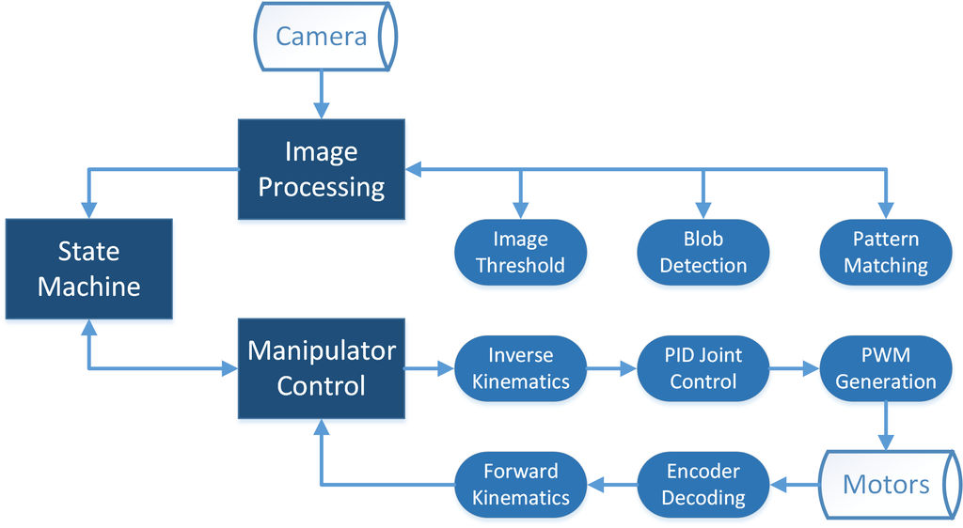

Figure 1: System structure of the goal directed line follower robot

The intention of these labs is to take the system structure shown in Figure 1 and break it down into a hierarchy of lab experiences which culminate in a complete working system like that shown above. Lab 1 and 4 are general experience labs where students can interact with the lowest and highest-level components of the system. Labs 2 and 3 are more structured, with students working through several intermediate concepts before applying those concepts in a design challenge.

### Lab 1: Interfacing with Motors

This lab consists of two lab sessions. One of which focusses on measuring angular displacement using encoders. The second session covers the concept of PWM signal generation and how PWM signals are used to drive motors. Both of these concepts are discussed in the context of ultimately controlling the position of the DC motor.

### Lab 2: Controlling Manipulators

This lab begins with a session on the general concept of closed loop PID control as applied to the angular position of a single actuator. Over the next two sessions, the concepts of forward and inverse kinematics are covered to relate the actuator joint position control to task space position control. Finally, these concepts are combined in a manipulator control challenge.

### Lab 3: Processing Images

This lab covers a wide range of topics in image processing. There are concept labs in image thresholding, blob detection, and pattern matching. These concepts are interlinked and the importance of complete image processing sequences is discussed. Once students are comfortable with these tools, the lab culminates with an image processing challenge.

### Lab 4: System Level Control

This lab is made up of two sessions. The first is an introductory lab on the concept of state machines. In this lab students will be introduced to the rudiments of machine intelligence. The second session is a culmination of all the earlier lab topics as students work to complete a line following robot using the tools of manipulator control, image processing, and state machines.

## Lab Tools and Technology

### Platform: NI ELVIS III

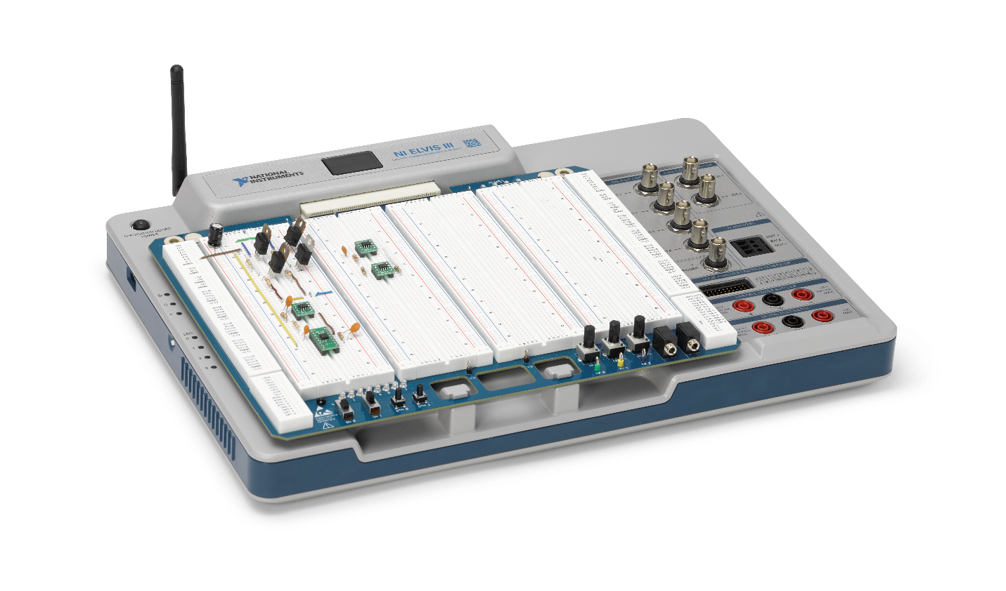

The NI Educational Laboratory Virtual Instrumentation Suite (NI ELVIS) is an engineering laboratory solution for project-based learning that combines instrumentation and embedded design with a web-driven experience to create an active learning environment in the lab and studio and flipped classrooms, delivering a greater understanding of engineering fundamentals and system design. NI ELVIS addresses engineering curriculum by integrating project-based learning, teamwork, and design with course-specific application boards and labs developed by experts from education and industry. NI ELVIS, as a programmable platform, gives educators the ability to scale to future multidisciplinary applications driving student employability.

**

Learn more at [http://www.ni.com/en-us/support/model.ni-elvis-iii.html](http://www.ni.com/en-us/support/model.ni-elvis-iii.html%20)

### Hardware: Quanser Mechatronic Systems Board



Designed exclusively for the NI ELVIS platform, the application board takes full advantage of accurate timing and control of FPGA-based reconfigurable I/O. Students investigate and implement various sub-components of a mechatronic system from PWM generation, manipulator control and kinematics, to image processing, and state machines. With the manipulator-mounted camera, customizable task space image overlays, and modifiable LabVIEW controllers, the application board can be easily adapted to a wide range of mechatronics application areas such as line following and autonomous navigation.



Learn more at <http://www.ni.com/en-us/support/model.quanser-mechatronics-systems-board-for-ni-elvis-iii.html>

### Software: LabVIEW

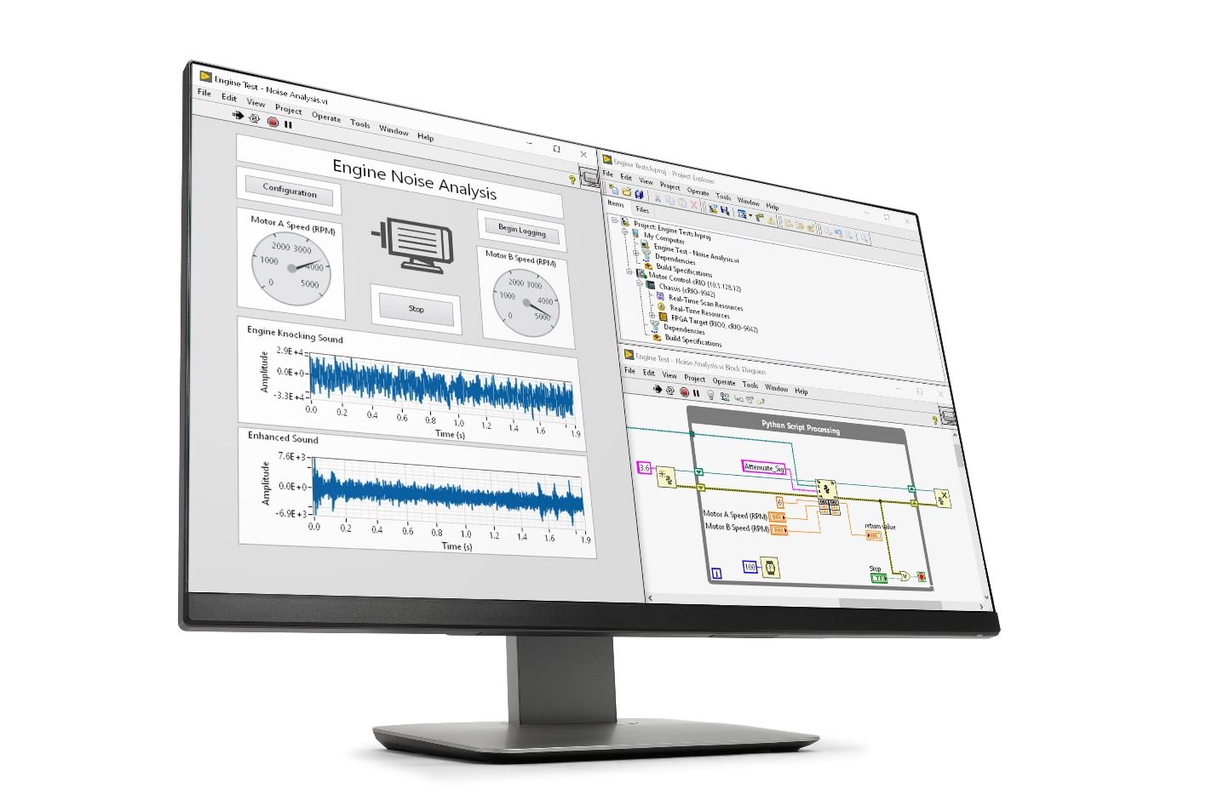

LabVIEW is systems engineering software for applications that require test, measurement, and control with rapid access to hardware and data insights. A widely-used, industry-standard tool for engineering system design, LabVIEW offers a graphical programming approach that helps visualize every aspect of an application. This visualization makes it easy to design engineering systems, convey concepts, and help students focus their time on the theory rather than get bogged down in the low-level implementation.

**

Learn more at <http://www.ni.com/en-us/shop/labview/labview-details.html>

# Lab 2: Controlling Manipulators

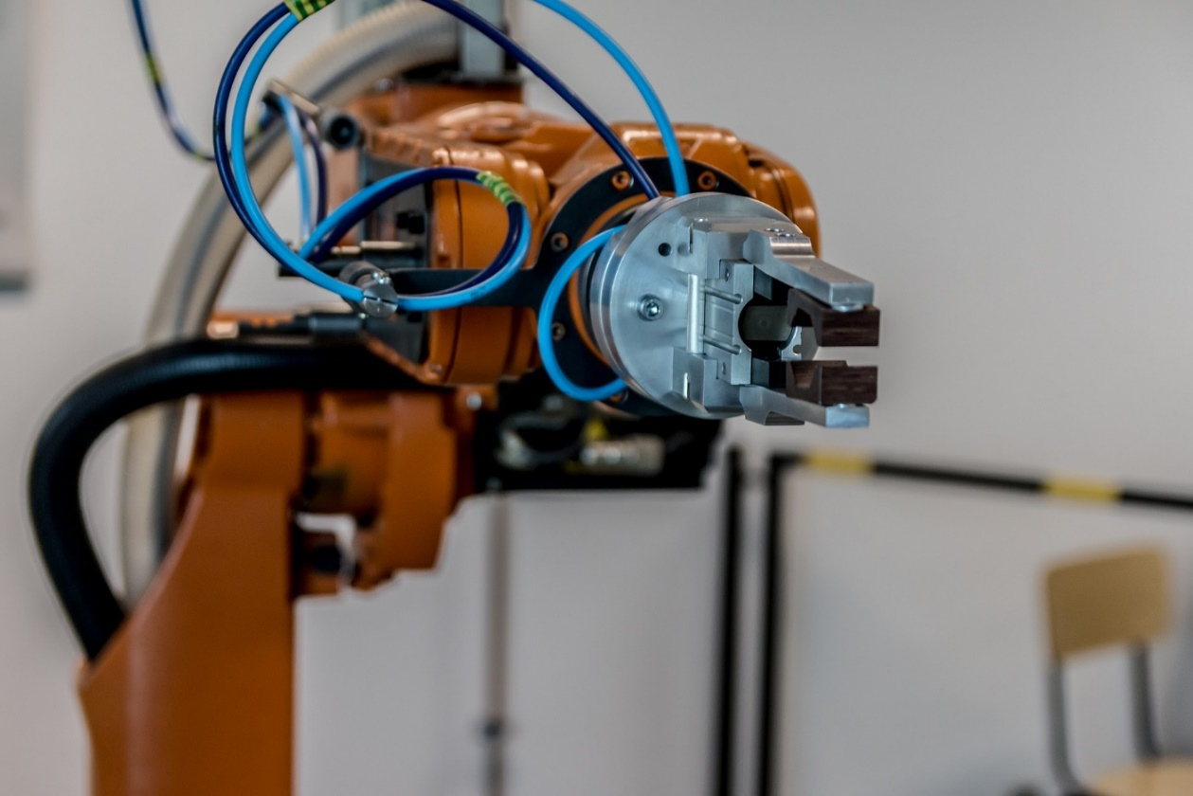

Figure 0-1: An industrial robot arm is a type of serial manipulator which utilizes task and joint-space control

In many manipulator systems, control of the behaviour of the system is managed using joint level algorithms. The user specifies a joint position, and a closed loop control system is used to drive the joint to that value. Such is the case with the Quanser Mechatronic Systems board, as illustrated in the PID Joint Control lab. However, in most cases the user does not specify a joint position, but rather a task-space point relative to the end-effector. In such systems, the desired task-space position is first converted into a joint-space position, where the control action is applied. The actual joint position is then converted back into the task-space to be able to monitor where the system is actually going. A final step is then often taken to include an additional task-space controller to ensure that the path traversed by the manipulator is correct.

This type of control design separates the system’s kinematics from the path planning algorithm. Users can then use the same path planning algorithm on a variety of manipulators with different kinematics, because the task-space trajectories do not depend on the kinematics of the manipulator directly.

## Learning Objectives

After completing this lab, you should be able to complete the following activities.

1. Understand the purpose of proportional, derivative and integral feedback control
2. Tune PID gains to produce acceptable system responses
3. Describe the theory and application of forward kinematics
4. Describe the theory and application of inverse kinematics
5. Design a PID controller to produce a manipulator output with minimum error
6. Design a PID controller to produce a manipulator output with maximum tracking speed

## Required Tools and Technology

|  |  |
| --- | --- |
| Platform: NI ELVIS III | * View User Manual   http://www.ni.com/en-us/support/model.ni-elvis-iii.html |
| Hardware: Quanser Mechatronic Systems Board | * View User Manual   http://www.ni.com/en-us/support/model.quanser-mechatronics-systems-board-for-ni-elvis-iii.html |
| Software: LabVIEW Version 18.0 or Later  Toolkits and Modules:   * LabVIEW Real-Time Module * LabVIEW FPGA Module * NI ELVIS III Toolkit * Vision Acquisition Software * Vision Development Module | * Before downloading and installing software, refer to your professor or lab manager for information on your lab’s software licenses and infrastructure * Download & Install for NI ELVIS III   <http://www.ni.com/academic/download>   * View Tutorials   http://www.ni.com/academic/students/learn-labview/ |

## Expected Deliverables

In this lab, you will collect the following deliverables:

* Recorded behavior of a PID joint controller under P, PD and PID control
* Manually tuned gains for a PID controller to meet design requirements
* Recorded outputs of a forward kinematic algorithm
* Recorded outputs of an inverse kinematic algorithm
* Experimentally tuned gains for a PID controller to maximize velocity on a circular path
* Experimentally tuned gains for a PID controller to minimize position error on a square path

Your instructor may expect you complete a lab report. Refer to your instructor for specific requirements or templates.

## Section 1: PID Joint Control

### 1.1 Theory and Background

#### Response Characteristics

A typical response to a desired step signal of R0 at time t0 is shown in Figure 1-1. The maximum value of the response is denoted by the variable ymax and it occurs at a time tmax. The percent overshoot is found using the formula

Equation 1-1

$PO= \frac{100(y_{max}-R_{0})}{R_{0}}$.

From the initial step time t0, the time it takes for the response to reach its maximum value is,

Equation 1-2

$$t_{p}= t_{max}-t_{0}.$$

This is called the peak time of the system.

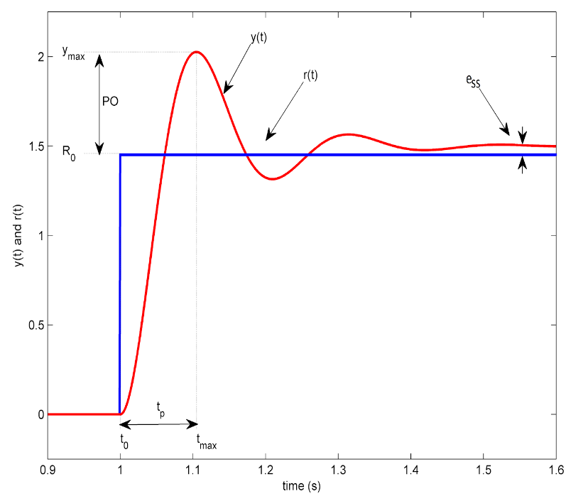

Figure 1-1 Standard second-order step response

Lastly, the difference between the desired value R0 and the actual value once the response settles, is called the steady state error ess.

#### Proportional Compensation

A proportional compensator drives the plant based on the difference between the current position of the system and the desired position. This contribution of this difference to the control response is tuned by the proportional gain kp which can be found either experimentally or calculated based on system requirements such as rise time. Greater proportional gain will result in a system with a shorter rise time, that is, the time needed for the system to reach point close to the desired position. However, since the system is constantly accelerating toward the setpoint, large proportional gains will generally lead to a system with large overshoot and a slow settling time, and oscillations about the desired set point.

#### Derivative Compensation

To deal with the overshoot and oscillation caused by a proportional compensator, many systems implement a derivative compensator in parallel. This compensator drives the plant based on the rate of change of the position error (or error velocity) of the system. As with proportional control, this derivative is magnified by the derivative gain kd. The derivative compensator effectively acts as added damping in underdamped systems. To improve the stability of systems with derivative compensation, low-pass filtering is often added to prevent spikes in the derivative component of the compensation due to signal noise.

#### Integral Compensation

In many cases, the combination of proportional and derivative gains will result in a system that does not settle sufficiently close to the setpoint. In this case, an integral compensator may be added. This compensator drives the system based on the accumulated error over time magnified by the integral gain ki. This component of the controller increases the longer the system remains far from the setpoint. As the integral gain responds to large changes in error, such as step changes in setpoint, it can cause the current value to overshoot the setpoint value.

#### PID Control

The proportional, integral, and derivative control can be expressed mathematically as follows

Equation 1-3

$$u\left(t\right)= k_{p}e\left(t\right)+k_{i}\int_{0}^{t}{e\left(τ\right)dτ}+k_{d}\frac{de(t)}{dt}.$$

The corresponding block diagram is given in Figure 1-2. The control action is a sum of three terms referred to as proportional (P), integral (I) and derivative (D) control gain. The controller in equation 3 can also be described by the transfer function

Equation 1-4

$C\left(s\right)= k_{p}+\frac{k_{i}}{s}+k_{d}s$.

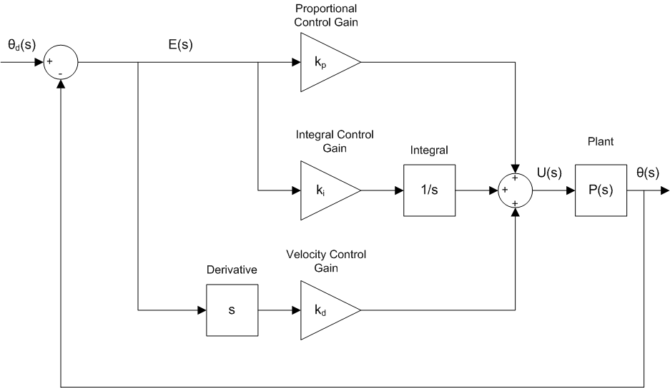

Figure 1-2: Block diagram of PID control

The functionality of the PID controller can be summarized as follows. The proportional term is based on the present error, the integral term depends on past errors, and the derivative term is a prediction of future errors. Attempts to implement such a PID controller may not lead to a good system response for real-world systems, because measured signals always include measurement noise. As described in the derivative compensation above, a low-pass filter is used to suppress measurement noise. The combination of a first order low-pass filter and the derivative term results in a high-pass filter H(s), which is used instead of the direct derivative.

A standard methodology in tuning the system gains manually consists of the following steps:

1. Set the derivative and integral gains to 0, and gradually increase the proportional gain till sustained oscillations are observed.
2. Increase the derivative gain gradually till the oscillations disappear and the system is critically damped. Any further damping will increase the rise time further.
3. Increase the integral gain until the steady state error falls within the desired error threshold, while adjusting the proportional gain to compensate for additional overshoot.

This process is often iterative, especially when an integral term is used. The proportional and derivative gains may have to be tuned to compensate for the addition of the integral term. Retuning may also be required if the sampling rate changes, or the nature of disturbance in the system changes (for example, the damping in the joints).

#### Voltage Saturation

In proper control system design, the voltage commanded by the controller should never exceed the maximum voltage that can be handled by the system, in this case, being the supply voltage of the ELVIS III platform to the DC motor. The Mechatronic Systems board powers the motors from the 5 volt supply, meaning the command voltage limit is ±5 V. While there is a non-linear voltage saturation inherent in the electronics of the application board, it is useful to keep this limitation in mind when designing a controller as the system will not behave as predicted if the controller is commanding voltages outside this range.

### 1.2 Implement

In this activity you will observe the internal workings of the PID controller. You will then go through the process of tuning a PID controller for a single motor to within required parameters.

1. Open the project **Mechatronic Systems.lvproj**, and under ELVIS III > Labs, open **PID Joint Position Control.vi**. Browse to the block diagram, and inside the loop labelled **PID Joint Position Control Loop**, open the sub-VI labelled **PID.vi** which should be similar to Figure 1-3.

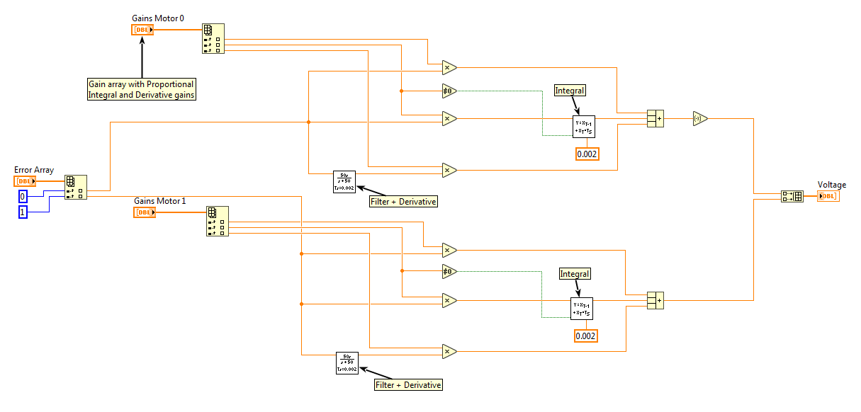

Figure 1-3: Internal structure of the PID control subVI

1. Compare this implementation of PID control to the block diagram shown in Figure 2. Note that this VI multiplies the error by the proportional gain, the integral of the error by the integral gain, and the derivative of the error by a derivative gain. Also note that the Integrator block must be added after the integral gain. If the integrator is added before, it will continue integrating the errors even if the integral gain is zero, which will cause large control commands when the integral gain is raised to a non-zero value for the first time.
2. Close **PID.vi**. Making sure that all the gain controls are set to zero, run **PID Joint Position Control.vi**. Once the **Calibrated** indicator is lit, hold the arm connected to motor 1 (closest to the front of the board) against the hard-stop between the arms, preventing any motion.
3. While holding this arm still, increase the kp gain to 0.5. Capture a plot of the system response at this gain.
4. Capture two more response plots, first with kp=1.5, and then kp=3.0.
5. Find a proportional gain that gives the response a peak time of less than 0.5 seconds, with as little overshoot as possible. Record the gain, and note the other behavior of the manipulator (overshoot and settling time).
6. Increase kd to 0.25, and then set kp to 5. Capture a plot of the system response with these settings.
7. Capture two more response plots, first with kd=0.5, and then kd=1.5.
8. Set the gains to kp=5 and kd=0.65, and record the steady state error.
9. Keeping the previous kp and kd gains, set ki = 0.5. Capture a plot of the system response with these settings.
10. Capture two more response plots, first with ki=1, and then ki=1.5.
11. Set kp, kd and ki gains to 5, 0.65 and 1 respectively.
12. Tune the PID gains so that the system meets the following requirements:
    1. Peak overshoot less than 5%
    2. Peak time of 0.5 seconds
    3. Steady state error less than ±2%
13. Record the gains when the system meets these requirements.
14. Capture both the response plot and the command voltage plot for this state.

### 1.3 Analyze

1-1 Describe how the proportional gain kp should theoretically affect the system response. Based on your expectations, comment on your plots and results from steps 4 and 5.

1-2 What was your gain in step 6? Based on the response, is it practical to use purely proportional control? Why or why not?

1-3 Describe how the derivative gain kd should theoretically affect the system response. Based on your expectations, comment on your plots and results from steps 7 and 8.

1-4 How can the steady state error in step 9 of the lab procedure be eliminated? Explain how this works from a theoretical standpoint.

1-5 Comment on your plots and results from steps 10 and 11.

1-6 What were the PID gains required to meet the response requirements? Attach your response plot with the requirements met.

1-7 Describe your tuning process, were there any requirements which were more difficult to achieve than others?

1-8 Analyze the command voltage plot. What is the peak commanded voltage? Is this problematic?

1-9 How might the position command be modified to mitigate any issues with the command voltage?

## Section 2: Forward Kinematics

### 2.1 Theory and Background

#### Kinematic Equations

For any robotic system, forward kinematics involves determining the end-effector position, given the manipulator state. For the Mechatronic Systems Board manipulator shown in Figure 2-1, this formally corresponds to finding the task-space (end effector) coordinates

Equation 2-1

$\vec{E}= \left[\begin{matrix}E_{x} \\ E_{y}\end{matrix}\right]$,

given the joint-space coordinates

Equation 2-2

$\vec{θ}= \left[\begin{matrix}θ_{0} \\ θ_{1}\end{matrix}\right]$.

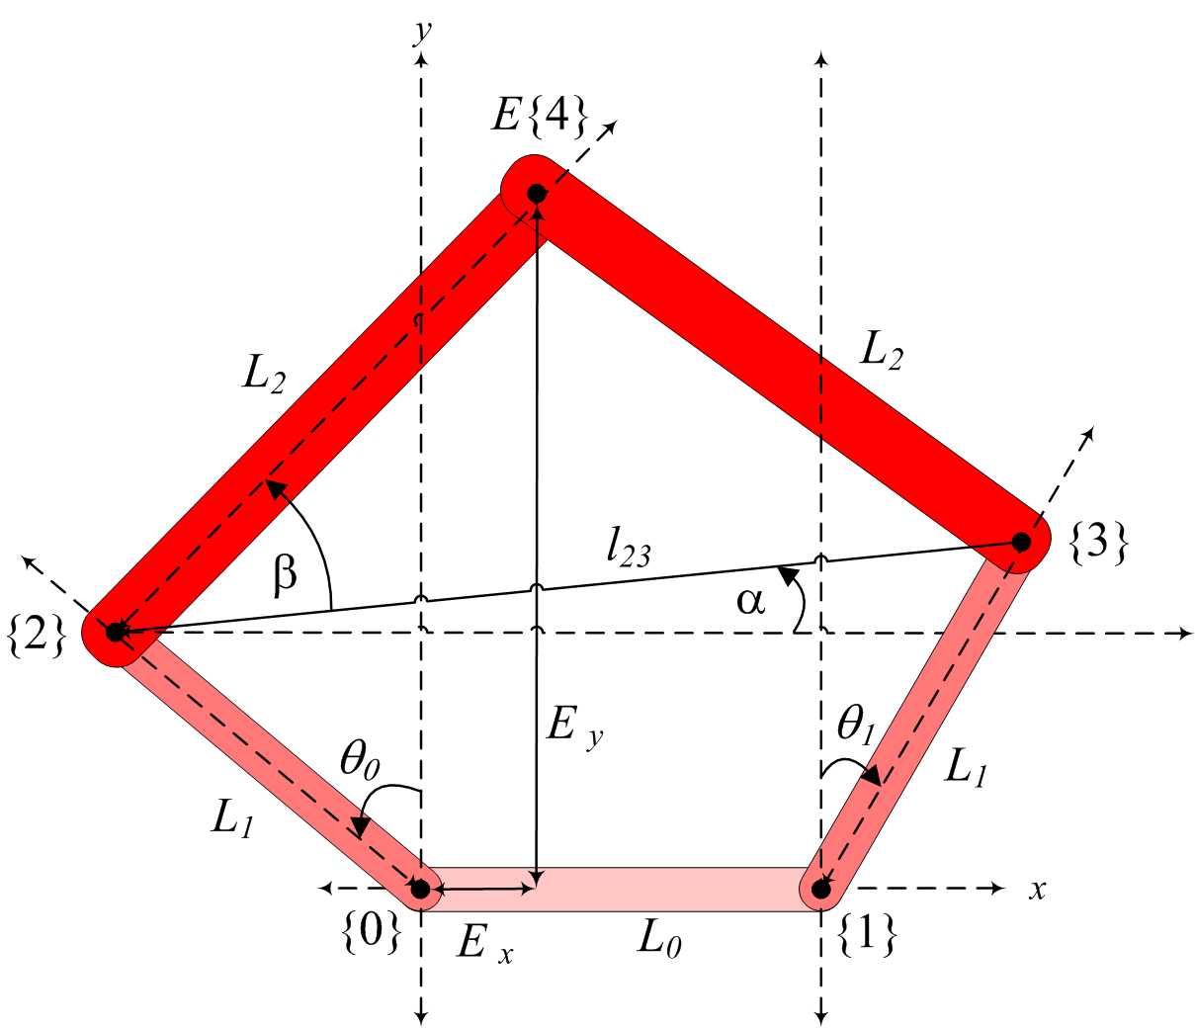

Figure 2-1 Mechatronic Systems Board kinematic diagram

The forward kinematics equations can be developed by first relating the coordinate positions of frame {2} and {3} in terms of $\vec{θ}$

Equation 2-3

$$P_{2,x}=-L_{1}\sin{θ_{0}} \\ P_{2,y}=L_{1}\cos{θ_{0}} \\ P_{3,x}=L_{1}\sin{θ_{1}}+L_{0} \\ P_{3,y}=L_{1}\cos{θ_{1}}$$

Followed by relating them to the position of frame {4}, that is, $\vec{E}$

Equation 2-4

$$l_{23}=\sqrt{{(P_{3,x}-P_{2,x})}^{2}+{(P_{3,y}-P_{2,y})}^{2}} \\ α= \tan^{-1}\left(\frac{P_{3,y}-P_{2,y}}{P_{3,x}-P_{2,x}}\right) \\ β= \cos^{-1}\left(\frac{l_{23}}{2L_{2}}\right) \\ E_{x}=P_{2,x}+L_{2}\cos{(α+β} \\ E_{y}=P_{2,y}+L_{2}\sin{(α+β)} \\ θ_{E}=α+β$$

The link parameters for the Mechatronic Systems board are provided in Table 2-1.

*Table 2-1 Application board kinematic parameters*

|  |  |  |
| --- | --- | --- |
| **Parameter** | Description | Value |
| L0 | Fixed length between two motors | 7.6 cm |
| L1 | Length of links {0}-{2} and {1}-{3} | 8.4 cm |
| L2 | Length of links {2}-{4} and {3}-{4} | 12.6 cm |

### 2.2 Implement

1. Open the project **Mechatronic Systems.lvproj**, and under ELVIS III > Labs, open **Forward Kinematics.vi**. Browse to the block diagram, and inside the loop labelled **Forward Kinematics Loop**, open the subVI labelled **Fwd Kin.vi**.
2. Complete the model using the example in Figure 2-2 as a reference. The code is based on Equations 2-3 and 2-4.

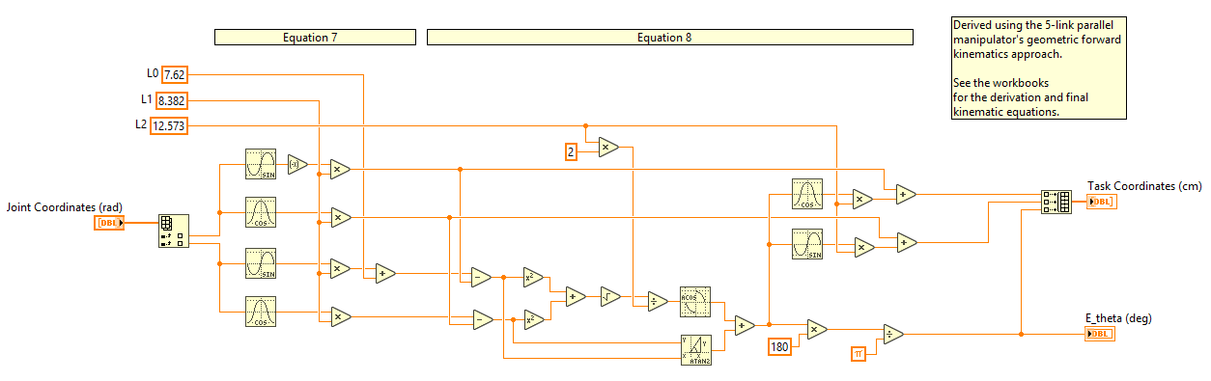

Figure 2-2: Forward kinematics formulation in LabVIEW

1. Test the VI with the following values for $\vec{θ}$ and record the coordinate outputs.
$$\vec{θ}=\left[\begin{matrix}0 \\ 0\end{matrix}\right] , \left[\begin{matrix}π/2 \\ 0\end{matrix}\right] , \left[\begin{matrix}0 \\ π/2\end{matrix}\right]$$

2. Close **For Kin.vi** and run **Forward Kinematics.vi**. Make sure that the coloured city map is affixed in position under the manipulator arm.
3. Once the **Calibrated** indicator is lit, move the manipulator around manually to the airport (), school (), and library () symbols, and try to get them as close to the center of the image as possible. Record the coordinates of the symbols.
4. With the VI still running, manually move the manipulator around the extreme limits of the task space. Capture a plot of the manipulator path which shows the entire outline of the workspace.
5. Stop the VI.

### 2.3 Analyze

2-1 Report your results from step 3. What do these task coordinates represent?

2-2 Table 2-2 gives the theoretical coordinates of several of the icons. Compare these coordinates to those you recorded in step 5. Are they similar? If there is error, comment on possible causes.

*Table 2-2 Theoretical symbol coordinates*

|  |  |  |
| --- | --- | --- |
| **Symbol** | Ex | Ey |
|  | 4.7 cm | 6.3 cm |
|  | 6.3 cm | 12.3 cm |
|  | 6.9 cm | 17.8 cm |

2-3 Is the task space you outlined in step 6 symmetric? Why or why not? Explain.

## Section 3: Inverse Kinematics

### 3.1 Theory and Background

#### Kinematic Equations

For any robotic system, inverse kinematics involves determining the manipulator state given the end-effector position. For the Mechatronic Systems Board manipulator shown in Figure 3-1, this formally corresponds to finding the joint-space coordinates

Equation 3-1

$\vec{θ}= \left[\begin{matrix}θ_{0} \\ θ_{1}\end{matrix}\right]$,

given the joint-space coordinates

Equation 3-2

$\vec{E}= \left[\begin{matrix}E_{x} \\ E_{y}\end{matrix}\right]$.



Figure 3-1: Mechatronic Systems Board kinematic diagram

The forward kinematics equations can be developed using a geometric approach as follows:

Equation 3-3

$$l_{04}=\sqrt{{E_{x}}^{2}+{E_{y}}^{2}} \\ α=90-\tan^{-1}\left(\frac{E_{y}}{E_{x}}\right) \\ β=\cos^{-1}\left(\frac{{L_{1}}^{2}-{L_{2}}^{2}+{l_{04}}^{2}}{2L_{1}l_{04}}\right) \\ θ_{0}=β-α$$

Equation 3-4

$$l_{14}=\sqrt{{\left(L_{0}-E_{x}\right)}^{2}+{E_{y}}^{2}} \\ γ=90-\tan^{-1}\left(\frac{E_{y}}{{L_{0}-E}_{x}}\right) \\ δ=\cos^{-1}\left(\frac{{L_{1}}^{2}-{L_{2}}^{2}+{l_{14}}^{2}}{2L_{1}l_{14}}\right) \\ θ_{1}=δ-γ$$

Note that using the inverse cosine works for this situation, because β and δ are in the open interval (0,π).

The link parameters for the application board are provided in Table 3-1.

*Table 3-1: Application board kinematic parameters*

|  |  |  |
| --- | --- | --- |
| **Parameter** | Description | Value |
| L0 | Fixed length between two motors | 7.6 cm |
| L1 | Length of links {0}-{2} and {1}-{3} | 8.4 cm |
| L2 | Length of links {2}-{4} and {3}-{4} | 12.6 cm |

### 3.2 Implement

1. Open the project **Mechatronic Systems.lvproj**, and under ELVIS III > Labs, open **Inverse Kinematics.vi**. Browse to the block diagram, and inside the loop labelled **Inverse Kinematics Loop**, open the subVI labelled **Inv Kin.vi**.
2. Complete the model using the code shown in Figure 3-2 as a reference. The code is based on Equations 3-3 and 3-4.

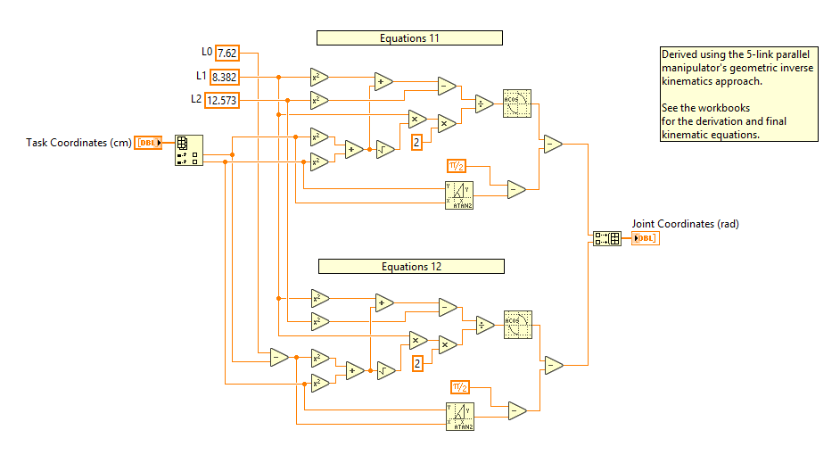

Figure 3-2: Inverse kinematics formulation in LabVIEW

1. Run the VI and wait for the **Calibrated**indicator to be lit.
2. Test the VI with the following values for $\vec{E}$ and record the joint coordinate outputs.
$$\vec{E}=\left[\begin{matrix}3.8 \\ 20.4\end{matrix}\right] , \left[\begin{matrix}-4.4 \\ 11.9\end{matrix}\right] , \left[\begin{matrix}12.1 \\ 11.9\end{matrix}\right]$$

3. Table 4 gives the theoretical location of several of the symbols on the map. Use **Inv Kin.vi** to convert these locations to joint-space angles.

*Table 3-2: Theoretical symbol coordinates*

|  |  |  |
| --- | --- | --- |
| **Symbol** | Ex | Ey |
|  | 4.7 cm | 6.3 cm |
|  | 6.3 cm | 12.3 cm |
|  | 6.9 cm | 17.8 cm |

1. Close **Inv Kin.vi** and run **Forward Kinematics.vi**. Make sure that the coloured city map is affixed in position under the manipulator arm.
2. Once the Calibrated indicator is lit, move the manipulator around manually to the Airport (), School (), and Library () symbols, and try to get them as close to the center of the image as possible. Record the joint coordinates of the symbols.
3. With the VI still running, manually move the manipulator around the extreme limits of the joint-space. Record the limits of the joint angles.
4. Stop the VI.

### 3.3 Analyze

3-1 Comment on your results from step 3. Where do these task-space coordinates fall in the joint-space?

3-2 Refer back to your joint-space angles found in step 6. Compare these coordinates to those you recorded in step 4. Are they similar? If there is error, comment on possible causes.

3-3 Based on the limits on the joint angles observed in step 7, what limits would you place on the commanded angles to prevent stalling the motors? Would this be more or less practical than placing limits on the task-space commands for the end-effector?

## Section 4: Manipulator Control

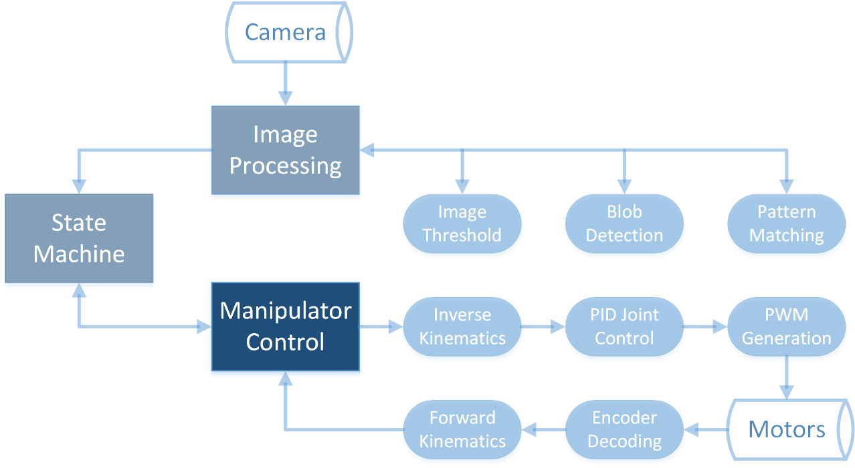

### 4.1 Theory and Background

#### Task-space Control

In many cases, the user might require the end-effector position $\vec{E}$ to follow certain trajectories, which belong in the task-space $E$, i.e.,

Equation 4-1

$$\vec{E}= \left[\begin{matrix}E_{x} \\ E_{y}\end{matrix}\right]∈E$$

However, the actual control is carried out in joint-space $Θ$, by following the joint trajectories $\vec{θ}$

Equation 4-2

$$\vec{θ}= \left[\begin{matrix}θ_{0} \\ θ_{1}\end{matrix}\right]∈Θ$$

This is accomplished through the use of inverse kinematics, forward kinematics and joint-space PID control, as shown in Figure 4-1. For more information on these processes, refer to the process level concept labs. Inverse kinematics converts the desired trajectory in task-space into a desired trajectory in joint-space. After implementing a PID controller in joint-space, the actual joint-space trajectories are converted back to task-space to compare them with the desired, as well as provide the end-effector orientation.

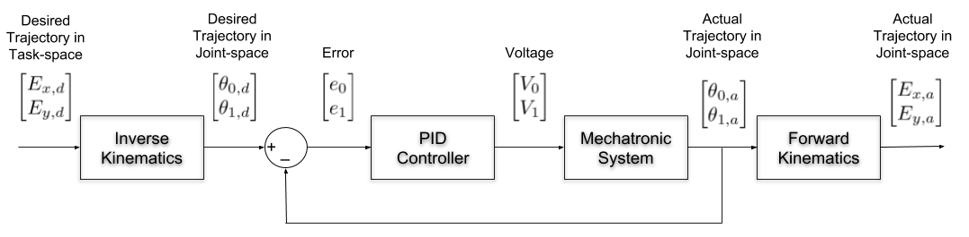

Figure 4-1: Task-space manipulator control loop

### 4.2 Implement

#### Manipulator Control Challenge

In this challenge, the Mechatronic Systems board manipulator must traverse a circular and square trajectory quickly and with low error. The trajectory generator for the circular path is decoupled from the manipulator controller, meaning the manipulator is constantly trying to catch up to the desired setpoint. The square trajectory is dependent on the manipulator controller, meaning the setpoint is commanded from an external supervisory loop which doesn’t command a new point until the current point is reached within a threshold. This way, every point along the trajectory is guaranteed to be reached at least once. This is useful in situations such as line-following, where new setpoints are generated from images taken by a sensor (camera) attached to the end-effector, which must be able to see the next desired point.

1. Open the project **Mechatronic Systems.lvproj**, and under ELVIS III > Labs, open **Manipulator Control.vi**.
2. Browse to the block diagram and observe that the manipulator control loop is structurally similar to that shown in Figure 4-1.

#### Minimizing Average Error

This system has been programmed to follow the desired trajectory points for 30 seconds, and calculate the average error using average value theorem. The defualt PID gains need to be tuned for proper performance.

1. Run the VI and wait for the **Calibrated**indicator to be lit.
2. Select the **Circle** trajectory and experiment with various PID gains.
3. Tune the PID gains to get an average task-space error of less than 0.15 cm.
4. Record your resultant gains and capture a plot of the path followed by the manipulator

Hint: The magnitude of the kp and ki gains in the PID Joint Control lab procedure were on the order of 5 and 1, respectively. This made sense because the desired set-point was 1 rad apart. Thus, when the system would view a 1 rad difference, it would apply a 5 V command. However, in these challenges as well as goal-directed line following algorithms you might encounter later, desired set points are very close by, for example, 1° (0.017 rad) apart. In such a case, the system will only apply 0.085V, which will not be sufficient to overcome friction. Thus, the gains have to be significantly higher than those in the PID Position Control laboratory experiment. Using higher gains provides higher control sensitivity when small error magnitudes are involved.

#### Minimizing Average Error and Loop Time

1. Change the trajectory to **Square**. This will present a different challenge as the manipulator will build up more momentum in long straight paths.
2. Set the **Error Threshold** to **0.3** in order to ensure the manipulator follows the desired path. Try running the controller.
3. Tune the PID gains to get an average task-space error less than 0.22cm with a time per loop of no more than 2 s (at least 10 loops per test).
4. Record the final tuned PID gains, and capture a plot of the path followed by the manipulator.
5. Change the Error Threshold to 0.1 and observe the change in performance. Consider the relationship between the common design considerations for tuning a manipulator controller including task-space error, speed, command voltage, etc.
6. Stop the VI.

# Lab 3: Processing Images

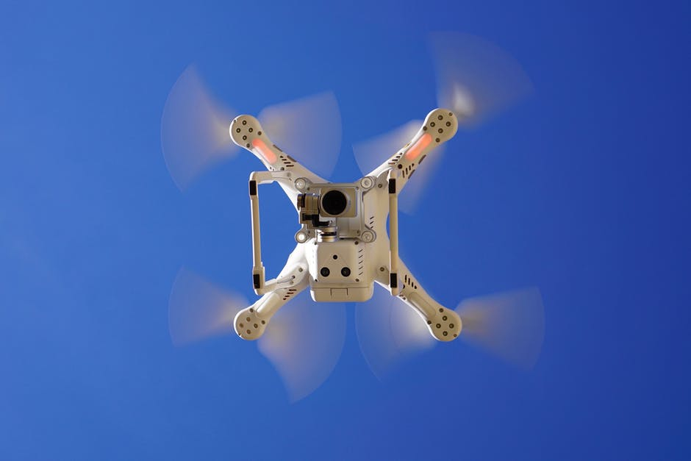

Figure 0-1: Cameras are no longer just payload on a drone, but often part of the control and navigation suite

Images represent a snapshot state of a dynamic world. The ability to capture and analyze visual data to extract pertinent information provides robots with an external reference for their surroundings. This is often used to improve the autonomy of robotic systems, especially for navigation. Image processing involves using a series of mathematical operations and algorithms to extract information from a given image, or from multiple images sequentially to understand how the environment is changing.

This lab applies process level algorithms including thresholding, pattern recognition and blob detection to detect and react to features below the manipulator.

## Learning Objectives

After completing this lab, you should be able to complete the following activities.

1. Describe the function and purpose of binary thresholding
2. Tune both grayscale and color HSL image thresholding
3. Describe the function and purpose of blob detection algorithms
4. Identify applications of blob detection in robotic processes
5. Describe the theory and purpose of pattern matching algorithms
6. Configure a pattern matching algorithm to deal with camera uncertainty
7. Apply thresholding, blob detection, and pattern matching to an autonomous vehicle context

## Required Tools and Technology

|  |  |
| --- | --- |
| Platform: NI ELVIS III | * View User Manual   http://www.ni.com/en-us/support/model.ni-elvis-iii.html |
| Hardware: Quanser Mechatronic Systems Board | * View User Manual   http://www.ni.com/en-us/support/model.quanser-mechatronics-systems-board-for-ni-elvis-iii.html |
| Software: LabVIEW Version 18.0 or Later  Toolkits and Modules:   * LabVIEW Real-Time Module * LabVIEW FPGA Module * NI ELVIS III Toolkit * Vision Acquisition Software * Vision Development Module | * Before downloading and installing software, refer to your professor or lab manager for information on your lab’s software licenses and infrastructure * Download & Install for NI ELVIS III   <http://www.ni.com/academic/download>   * View Tutorials   http://www.ni.com/academic/students/learn-labview/ |

## Expected Deliverables

In this lab, you will collect the following deliverables:

* Theoretically tuned HSL thresholding settings
* Manually tuned pattern matching algorithm settings
* Functional image processing application controller with traffic and landmark detection

Your instructor may expect you complete a lab report. Refer to your instructor for specific requirements or templates.

## Section 4: Image Processing

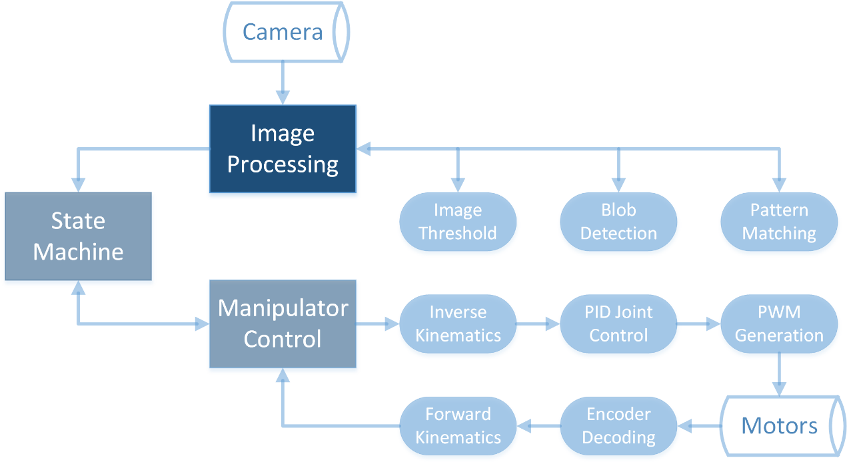

### 4.1 Theory and Background

#### Regions of Interest

In image processing an image may be overlaid with a Region of Interest or ROI. This indicates the portion of the picture which is important for a particular image processing task. It can be seen overlaid in green in Figures 4-1a-c. In this example the ROI is a square, but it can be any shape up to and including a freehand bounded space. An ROI is useful for constraining where a pattern matching algorithm is applied, or for generating image masks.

#### Image Masking

Before performing a task such as blob detection, it may be valuable to eliminate any data outside of the ROI. This is accomplished by using an image mask. An image mask is an array of binary data (generally represented with a black and white binary image). When the mask is applied to an image, any pixel in the mask which has value 0 will also have a value of 0 in the output. Pixels which are not 0 in the mask retain their original value. The result is to block out unwanted data so that only pixels in the ROI are retained.

#### HSL Thresholding

HSL thresholding is more complex than the grayscale thresholding covered in the image thresholding lab. This process allows for limits to be placed on the allowable values for any or all of the variables hue, saturation, and luminance. In order for a pixel to be white in the thresholded image it must satisfy *all* the threshold requirements. For instance one might limit the Hue threshold to a range of 75-95 to isolate only green pixels, and then further limit the luminosity to <128 to exclude white and off-white pixels.

#### Image Processing Algorithms

Image processing involves combining several tools to extract information from a given image. The input is usually a 2-D image, and the output depends on the algorithm used. The process usually starts with thresholding an image to categorize information based on what is required. For example, binary thresholding can be used to cluster red road information as white pixels, and all other information as black as shown in Figure 4-1a. Once the image is thresholded, it may be masked as shown in Figure 4-1c. Using further algorithms such as pattern matching and blob analysis, the user can identify certain particles from the cluster of road information, such as high traffic routes, (Figures 4-1b-c), or specific patterns (Figure 4-1d) etc.

|  |  |  |  |
| --- | --- | --- | --- |
| (a) Original | (b) Threshold | (c) Mask | (d) Pattern Match |

Figure 4-1: Image processing tools used to extract road or pattern information

### 4.2 Implement

#### Image Processing Challenge

In this challenge, the Mechatronic Systems board manipulator represents a car travelling along the roads on the city map. The car autonomously moves along the trajectory shown by the numbered waypoints in Figure 4-2. Along this trajectory, it encounters both red (high traffic) roads and green (low traffic) roads. It also passes several buildings indicated by icons. The following functionality is desired,

* When the car is travelling on a green road, it should travel at a constant rate of 0.5cm/s
* When the car is travelling on a red road, it must reduce its speed to 0.25cm/s
* When the car is passing the school (indicated by the icon) it must slow to 0.1cm/s

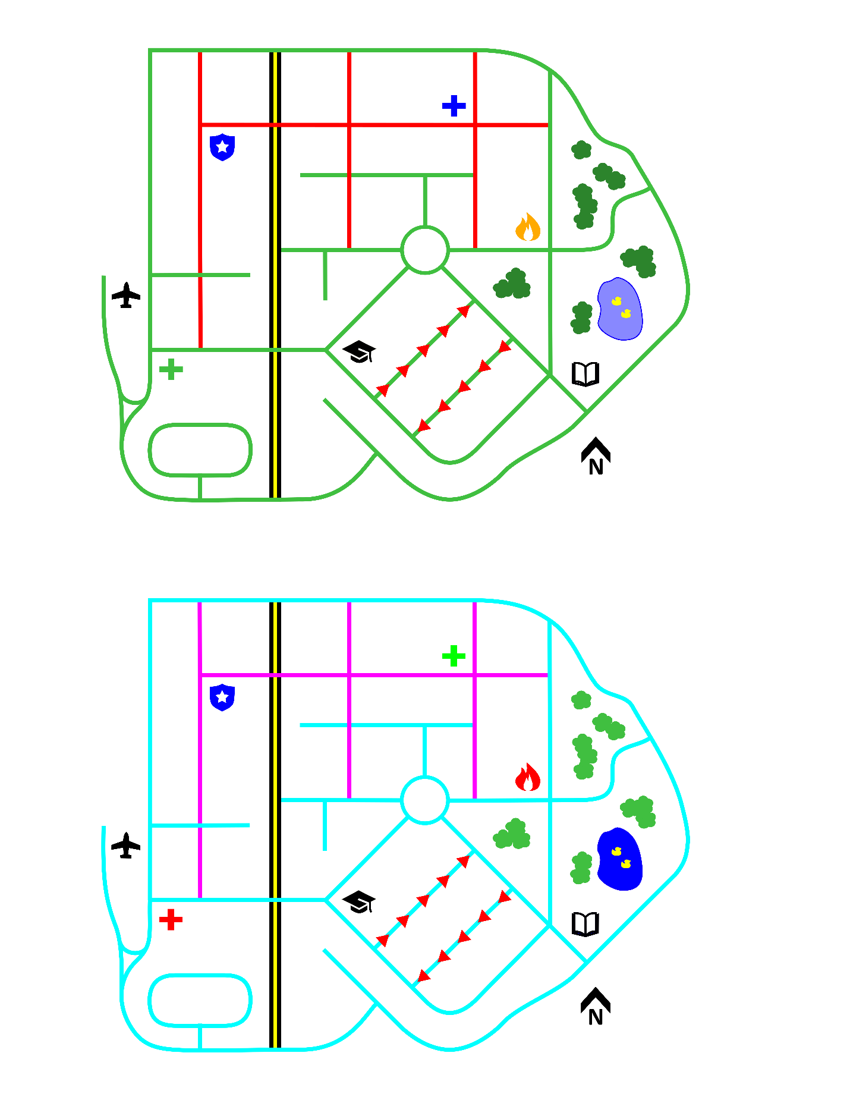

2

6

5

4

3

1

Figure 4-2: Car trajectory waypoints on city map

The structure of the system has already been implemented, your task is to tune the image processing algorithms and thresholds so that the desired behavior is achieved.

For this lab, ensure that the Mechatronic Systems board is placed in a bright environment. If lighting conditions are poor, the Mechatronic Systems board camera’s sensors automatically reduce their upper detection threshold to improve their sensitivity in the dark environment. However, this leads to image desaturation and other issues with image processing.

#### Detecting the School

The first step involves detecting the presence of the school icon in the image marked **Source Image**, using gray-scale thresholding and pattern matching.

1. Open the project **Quanser Mechatronic Systems Board.lvproj**, and under ELVIS III > Labs, open **Image Processing.vi**.
2. Set **Enable Motion** to OFF and run the VI.
3. Wait for the **Calibrated**indicator to be lit. The manipulator should be able to move freely.
4. Move the camera so that the school icon is well within the source image.
5. Adjust the **Grayscale Threshold** so that the school icon is clearly visible in the grayscale threshold image. Minimize non-black pixels which remain in the image as much as possible.
6. Adjust the **Minimum Match Score**so that the school icon is consistently identified as long as it is in the image.
7. Move the manipulator around the rest of the map, ensure that the **Minimum Match Score** is set high enough that other icons are not erroneously matched with the school icon.

Note: You may have to go back and adjust the thresholding and match score values so that the thresholding and pattern matching are robust and so that there are no false positives.

#### Detecting High-Traffic Roads

1. Move the camera so that both green and red roads are visible in the source image.
2. Adjust the saturation and luminance thresholds so that black and white pixels are excluded. Due to lighting conditions, it may not be possible to fully remove the black and white segments of the image using only saturation and luminance.
3. If necessary, adjust the hue threshold to fully remove the black and white segments. Further adjust the hue level to isolate green roads while excluding red roads.

Note: as you add threshold limits to the HSL threshold you may have to go back and adjust previous threshold limits iteratively to achieve the desired effect.

#### Results

When you have completed both challenges, set **Enable Motion** to ON. The camera should begin tracing the path shown above. If any behaviour is incorrect, set **Enable Motion** to OFF to resume debugging.

# Lab 4: System Level Control

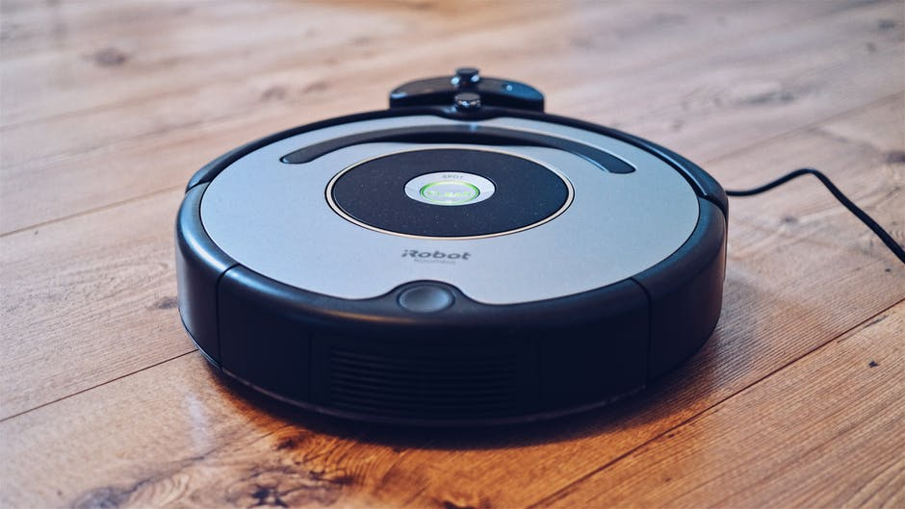

Figure 0-1: System level control applies a mechatronic system to a task such as autonomous cleaning

A state machine is an abstract machine that can automate systems involving sequential logic and decision making. State machines of particular interest to robotic systems are Finite-State Machines (FSM), which can be in one of many but finite stable states. The next state depends on the current state, the values of inputs, or in-state calculations.

State machines are used in logic circuits, describing and designing neurological systems, traffic lights, combination locks, washing machines, vending machines etc. In all of these systems there are predefined states that a system must autonomously traverse through.

Line following involves a robot making autonomous decisions related to navigation based on information it collects and processes. Goal-directed line following gives the robot a higher level purpose towards line following, such as getting from point A to point B. The overall coordinates of the two points are provided to the robot, but the pathway between them isn’t clearly deterministic, and the robot must decide a path on the fly.

## Learning Objectives

After completing this lab, you should be able to complete the following activities.

1. Describe the theoretical operation of state machines
2. Design a state-flow diagram for a finite-state machine
3. Develop a task-space algorithm to meet required performance goals
4. Explain the process of interconnecting low-level function loops
5. Calibrate thresholding algorithms for required behavior
6. Configure vision area of interest to limit input data
7. Analyze unexpected or erroneous behavior in task-space control

## Required Tools and Technology

|  |  |
| --- | --- |
| Platform: NI ELVIS III | * View User Manual   http://www.ni.com/en-us/support/model.ni-elvis-iii.html |
| Hardware: Quanser Mechatronic Systems Board | * View User Manual   http://www.ni.com/en-us/support/model.quanser-mechatronics-systems-board-for-ni-elvis-iii.html |
| Software: LabVIEW Version 18.0 or Later  Toolkits and Modules:   * LabVIEW Real-Time Module * LabVIEW FPGA Module * NI ELVIS III Toolkit * Vision Acquisition Software * Vision Development Module | * Before downloading and installing software, refer to your professor or lab manager for information on your lab’s software licenses and infrastructure * Download & Install for NI ELVIS III   <http://www.ni.com/academic/download>   * View Tutorials   http://www.ni.com/academic/students/learn-labview/ |

## Expected Deliverables

In this lab, you will collect the following deliverables:

* Functional state machine implementation for stitching together a complete task space image
* Functional line following controller with image processing and state logic

Your instructor may expect you complete a lab report. Refer to your instructor for specific requirements or templates.

## Section 1: State Machines

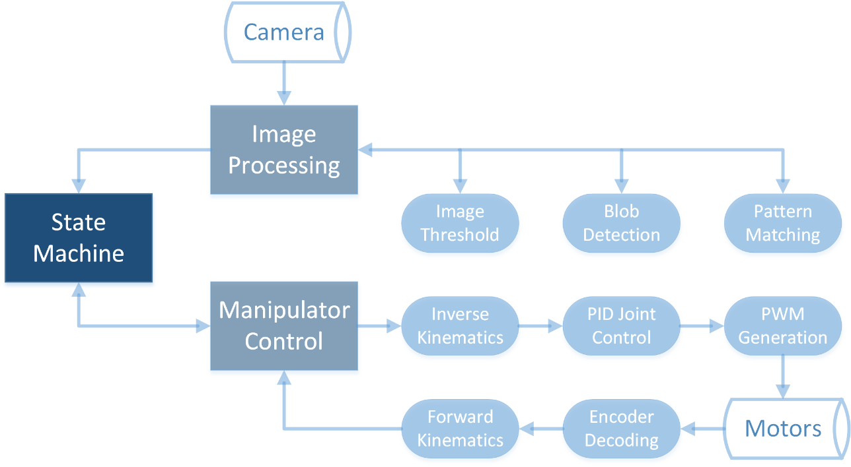

### 1.1 Theory and Background

#### State Flow Diagrams

A state machine should always have a beginning state, and an end state. The remaining states should always have at least one exit state other than the same state itself. A state flow diagram can represent the behaviour of a state machine, as shown in Figure 1.

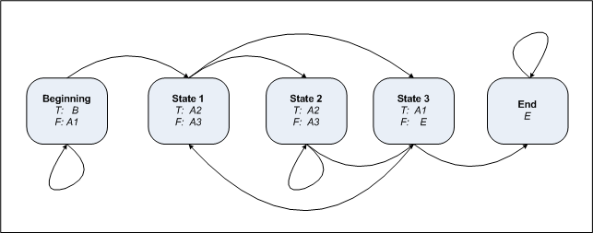

Figure 1-1: Example state flow diagram

In the example diagram above, the Beginning state can take the system to State 1 if an internal condition is FALSE, or keep it in the Beginning state otherwise. Similarly, State 1 can proceed to State 2 or State 3. State 2 can proceed to State 3 if a condition is FALSE, or remain in State 2 if TRUE. The latter could represent a case in which either a pause is required, or the system waits for an event to occur. State 3 either loops back to State 1 or proceeds to the End state, remaining there.

Consider the traffic light example shown in Figure 1-2. As long as the START condition remains true, the system will loop at the given times. A more complex example might have state transitions which were dependent on other variables such as time of day, vehicle sensors, or cross-walk buttons.

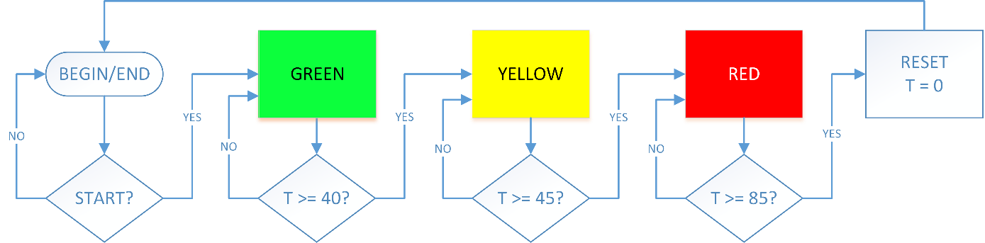

Figure 1-2: Example state machine flow chart for a traffic light

### 1.2 Implement

#### State Machine Challenge

In this challenge, simple rules will be used to create a system which scans part of the robot task space and stitches together a complete image of that space. This is analogous to a camera drone flying over an area and generating a complete aerial view from several images. The state machine must meet the following rules:

* When the system starts, the drone will go to a known start position.
* At any given time, the drone will be travelling in one of four directions; NE, SE, SW or NW.
* When the *GO* button is pressed, the drone will leave the start position in the NE direction.
* When the drone reaches one of the boundaries of a rectangular work area, it will turn 90 degrees and continue in one of the other directions.
* The drone will not leave the area bounded by 0 ≤ Ex ≤ 8 and 6 ≤ Ey ≤ 18

#### Configuring State Transitions

The first step involves detecting the presence of the school icon in the Source Image, using gray-scale thresholding and pattern matching.

1. Open the project **Mechatronic Systems Board.lvproj**, and under Quanser ELVIS III > Labs, open **State Machine.vi**.
2. Open the block diagram and look at the **State Machine** loop. The case structure which controls the state of the machine is already implemented for you.
3. Open the **Start** state in the case structure observe function of the select block, this block is key to the process of transitioning between states.
4. Switch to the **NE** state, which should be the initial state when the **GO** button is pressed. The desired task coordinate has been broken out into X and Y components and these are fed into comparator blocks. Note that because the X and Y axes are in the frame of reference of the arms, the **NE** direction relates to moving in the negative X and positive Y directions simultaneously.
5. Add values for each comparator, these should relate to the minimum value for the X direction, and the maximum value for the Y direction.
6. Note that both of the selector blocks are currently set to return to the **Start** state when triggered. Update the next state for the cases when the system reaches the X and Y limits in this state.
7. Copy the comparison and selector code you created in the **NE** state to the other three direction states. You will have to make sure that the correct comparison is being done depending on whether the X and Y values are increasing or decreasing.
8. Update the next state constants for each of the other three directions.
9. Run the VI.
10. Observe the behavior of the system. The system should travel NE until reaching the negative X limit then proceed SE until hitting the positive Y limit and proceeding SW and so forth.
11. If the system behavior is not as expected (that is a complete image of the map is not produced) you can debug the behavior by watching the **State** indicator on the front panel.

#### Adding a New State

Once the desired behavior has been accomplished, it may be necessary to add additional states to the machine. In this case, we want to add reset functionality which will return the drone to the Start position from any other state.

1. Open the **Reset** state. Note that the outputs of this state do not depend on the state input at all. This serves to return the state machine to a known configuration before returning to the **Start** state.
2. Connect the Reset button to a selector block such that from any state, the state machine moves to the **Reset** state when the **Reset** button is pressed.
3. Run the VI.
4. Once the manipulator has moved to the NE corner of the work space, press the **Reset** button and ensure that the **State** returns to **Start** and the manipulator returns to the start location.

#### Redesigning the State Machine

This state machine results in a “drone” which can stitch together a fairly complete image of the board, however there is significant overlap in the paths taken, and it is only suitable for square work areas. To explore the shortcomings of this approach, you can try to determine the state transition logic for a more complicated work space such as that shown in Figure 1-3.

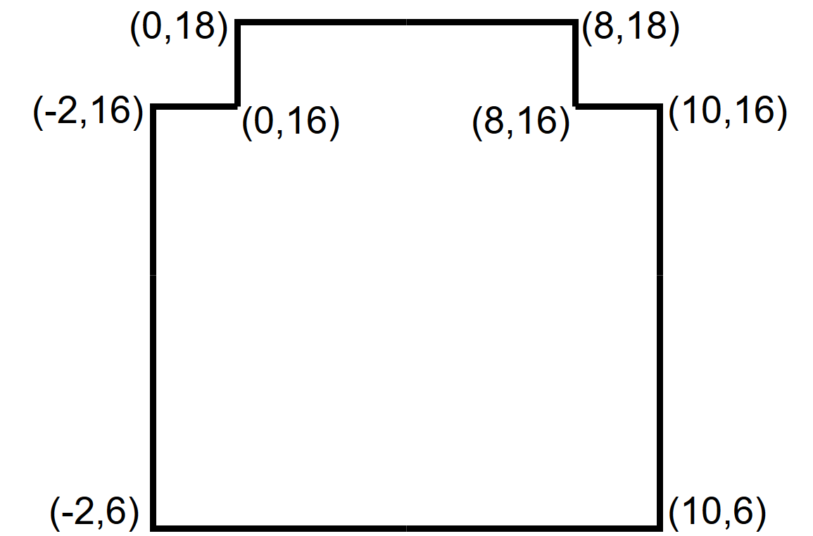

Figure 1-3: A more complete, but more convoluted workspace

It will quickly become clear that features such as the inner corners at (0,16) and (8,16) are problematic. By observing why these features cause complications one can develop a more flexible state machine. Additionally, there is an opportunity to redesign the state machine to make the process of imaging the full workspace more efficient by minimizing image overlap.

To this end, design a *completely new state machine*. This machine must:

* Completely traverse the workspace shown in Figure 1-3
* Minimize overlap in captured imagery during traversal
* Minimize time needed to stitch a complete image of the work space

Generate a state flow diagram for your machine. As an example, Figure 1-4 shows the state flow diagram for the machine implemented in the previous section.

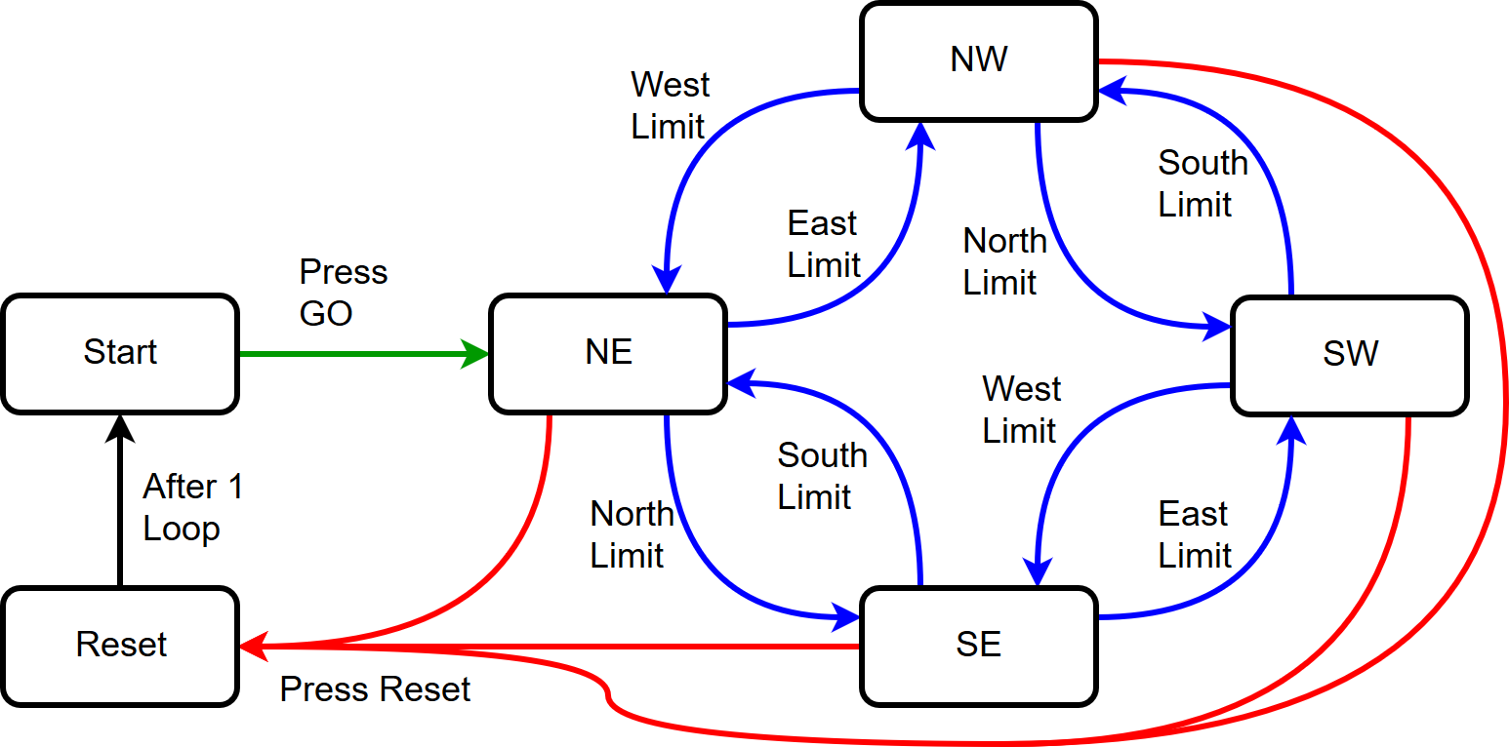

Figure 1-4: State flow diagram for the existing mapping drone state machine

Notes:

* In the state flow diagram shown in Figure 1-4 you may notice that the step from Reset to Start is triggered after 1 loop. You may want to leverage a loop counter to transition states after a certain amount of time, which will allow for travel over a known distance.
* It may be helpful for your problem solving to reframe the problem in another context, such as that of a robot vacuum or crop sprayer.
* For a more elegant solution, it may be worthwhile considering how flexible your solution is in terms of the shape of the workspace. Would your solution work in a non-rectilinear space? What if the workspace was the entire task space of the robot?

#### Optional: Implementing the New State Machine

It may be necessary to implement your state machine in the State Machine VI either for testing or to present a working exemplar for adjudication. In this case it is strongly suggested that you firmly establish the full list of states that will be required before modifying the **Enum** constant which is used to establish the set of states for the machine. Furthermore, it will likely be less work in the long run to completely delete the case structure within the state machine loop and create an entirely new case structure rather than trying to adapt the existing structure to the new state enumeration.

## Section 2: Goal-Directed Line Following

### 2.1 Theory and Background

#### System Functionality

Goal-directed line following brings image processing, manipulator control and state machine concepts together, to have the Mechatronic Systems board manipulator move from point A to point B autonomously, while only travelling along roads.

It is important that the three systems communicate information back and forth as shown in Figure 2-1.

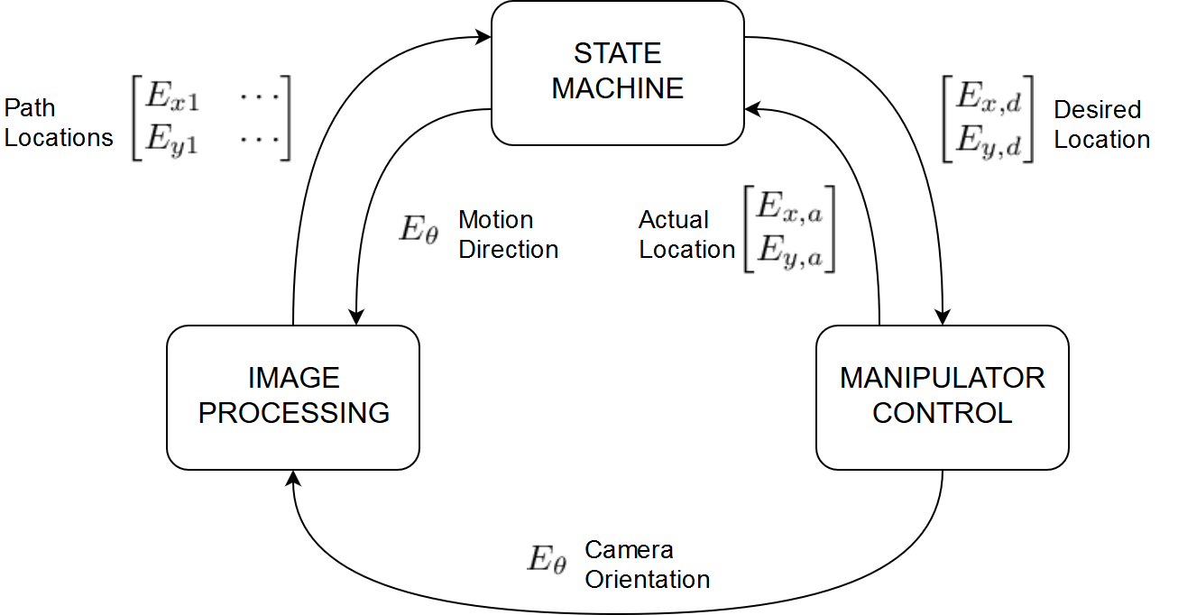

Figure 2-1: Communication between the three systems in goal-directed line following

#### Manipulator Control

The manipulator control loop is very similar to the one you saw in the Manipulator Control concept review. It receives the desired end-effector task coordinates from the state machine. It uses inverse kinematics (see Inverse Kinematics background section) to transform this into the desired joint coordinates. It uses a PID compensator (see PID Joint Control background section) to drive the manipulator to the joint coordinates. It transforms the actual joint coordinates into the actual task coordinates using forward kinematics (see Forward Kinematics background section), and passes this information to the state machine. It also uses forward kinematics to pass the camera orientation to the image processing loop. This is shown in Figure 2-2.

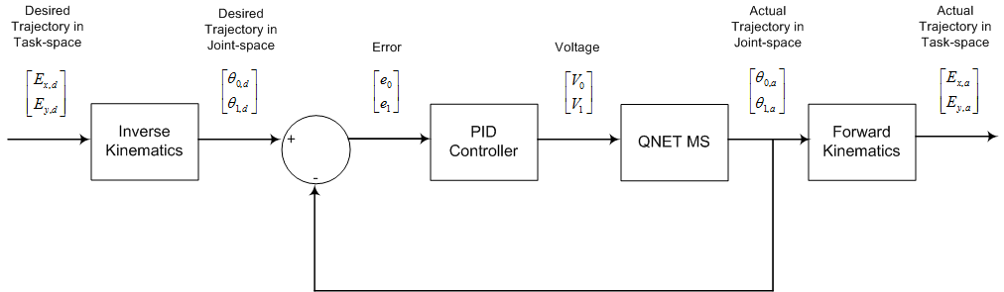

Figure 2-2: Manipulator control loop diagram

#### Image Processing

The image processing loop receives a grayscale image from onboard camera, and rotates it using information on the camera’s orientation from the manipulator control loop. It uses thresholding to convert the image into a binary format (see Image Threshold concept review), and applies an Area of Interest (AOI) overlay. This AOI is some fraction of a circle around the center of the image which represents what the robot can see, that is, the Field of View (FOV). Only roads which are visible and fall in the AOI can be “seen” and are available for the robot to follow. These visible particles in the AOI are then converted to task space locations and passed to the state machine. The complete image processing loop structure is shown in Figure 2-3

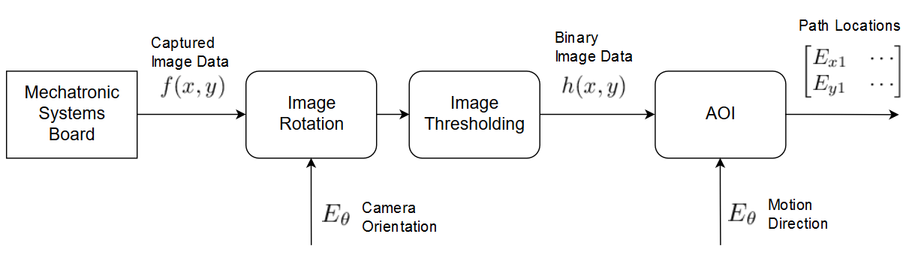

Figure 2-3: Image Processing loop diagram

#### State Machine

The state machine for this line follower has five states, which are shown in Figure 2-4 along with brief notes on the transition logic.

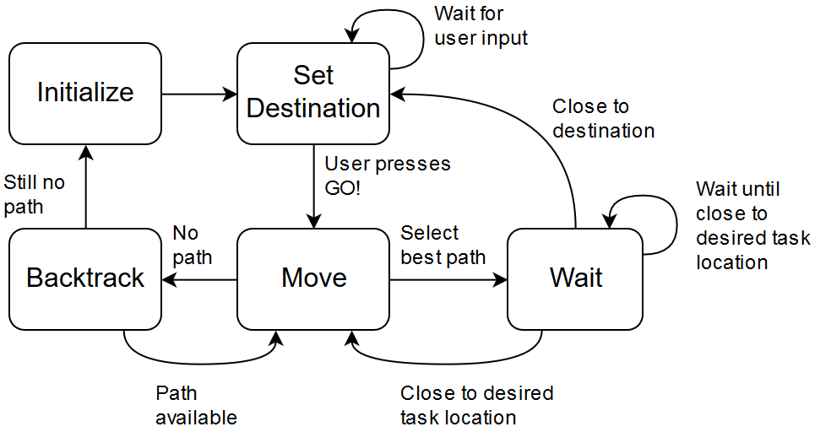

Figure 2-4: State machine diagram

In the **Initialize** state, the system creates overlays for the map to indicate the destination and robot location, and sets the initial position and path direction for the robot. This state is essentially a “reset” state which returns the robot to the START location on the map, facing west. The state machine then immediately proceeds to the **Set Destination** state.

The **Set Destination** state checks to see if the user has selected a destination. When the user clicks on the map, the destination coordinates are updated. When the destination has been set and the user presses the **GO** Button, the state machine proceeds to the **Move** state.

The **Move** state is the heart of the state machine. Here, the path locations from the image processing loop are compared to the destination coordinates and the path which is closest to the destination is selected. The desired task coordinate is updated and the state machine proceeds to the **Wait** state. If the list of path options is empty (that is, there are no roads visible in the AOI) the motion history is reversed. This effectively turns the robot around. In this case, the state machine proceeds to the**Backtrack** state.

In the **Wait**state, the system watches the actual task location of the manipulator and compares it to the desired task location as well as the ultimate destination coordinates. If the manipulator is sufficiently close to the desired task location, the system returns to the **Move** state. If the manipulator is sufficiently close to the ultimate destination, then the task is complete and the system returns to the **Set Destination** state to get a new user-defined destination. If neither case is true, the system waits while the motion control loop works.

The **Backtrack** state gives the image processing loop time to update the list of paths once the robot has reversed direction. If, after 500ms there are still no paths in the list, the system gives up and returns to the **Initialize** state to start over from the default configuration. Otherwise the system returns to the **Move** state and continues as normal.

The **Stop**state is not part of the regular operation and serves to clear the map when the VI stops. This state will supersede any other state transition and can be reached from any previous state by pressing the **STOP** button.

### 2.2 Implement

#### Connecting System Loops

1. Open the project **Mechatronic Systems Board.lvproj**, and under ELVIS III > Labs, open **Goal-directed Line Following.vi**. Open the block diagram.
2. Starting with the **State Machine Loop**, connect the **Desired task coordinates** output to the **Task coordinates (cm)** input of the **Inv Kin** subVI in the manipulator loop. This allows the state machine to command the location of the manipulator.
3. Also on the state machine, connect the **Manipulator path direction (deg)** output of the state machine to the **Path Direction** input on the image processing loop. This information is used to set the area of interest (AOI) in the image processing, essentially deciding what the manipulator can “see”.
4. Scroll down to the **Manipulator Control Loop**. Connect the **Task coordinates (cm)** output of the **Fwd Kin** subVI to the **Current task coordinates** input in the state machine, as well as the **Manipulator Location** input of the image processing loop. This allows these loops to make calculations about the next state, and the location of objects in the camera image.
5. Scroll up to the **Image Processing loop**. Connect the **Visible Paths** output to the **Path Options** input on the state machine. This allows the state machine to make decisions about what possible paths are available for movement.
6. Ensure that the VI is executable.

#### Line Following

1. Run the VI. Wait until the **Calibrated** indicator is lit.
2. Adjust the **threshold limit** sliders so that both red and green objects are clearly visible in the thresholded image.
3. Click on the silk image at the red X shown in Figure 2-5. This selects the final destination point.  
   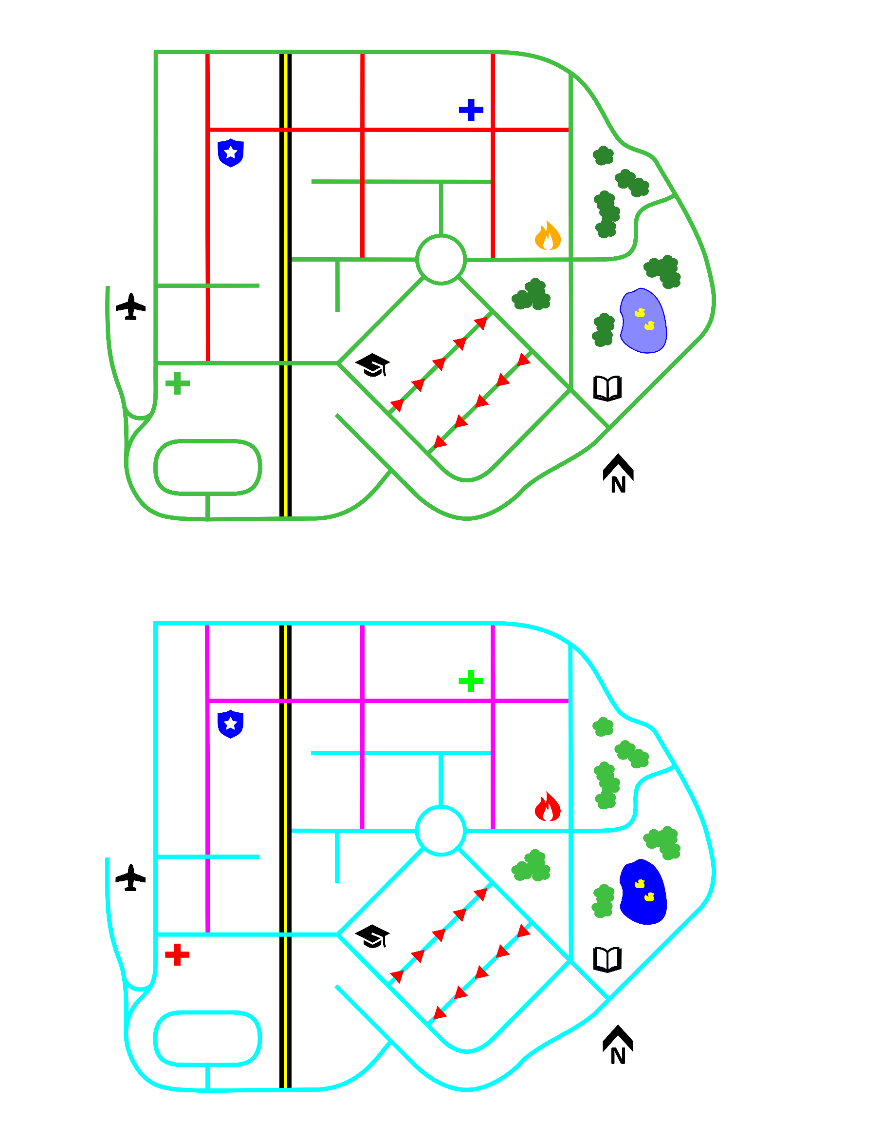

Figure 2-5: Final destination on the front panel silk image

1. Press the **GO** button and observe the motion of the manipulator.
2. Stop the VI.
3. In the block diagram, browse to the **Wait** state in the state machine. Take a look at code which checks if manipulator is close to the desired task coordinate. Note that the loop will continue to wait unless the task space error is less than 0.01 cm. Thus, the state machine waits until the manipulator is within 0.01 cm of the desired position. Change this number to 0.1 cm. Repeat steps 8 and 9, and make notes on the system behaviour and performance.

#### Adjusting the Field of View

1. Run the VI. Select the final destination indicated in Figure 2-6. How many paths can the manipulator take to reach this point? Click on the **GO** button. Does the manipulator reach the final destination? Stop the VI and take notes on the result.



Figure 2-6: New destination on the front panel silk image

1. Open the block diagram and find the **Field of View** constant which feeds into the **Process Image** subVI. Adjust the value to 90 and repeat step 9. Note that now, the robot can effectively only see in a narrow window in the direction of travel. Observe the behavior of the system.
2. Experiment with different values for the **FOV**. And find a value with balances the need to see multiple paths with the danger of getting trapped in dead end paths.

#### Avoiding Traffic

1. Press **Reset**so that you can freely move the manipulator.
2. Adjust the threshold limits such that the manipulator will be able to follow green roads but will not follow red roads.
3. Experiment with various destination points on the map. Note any map features which present issues for navigation.